Steckbrief: Alpensteinbock
______________________________________________________________________________________________________________________
Aussehen
 |  | 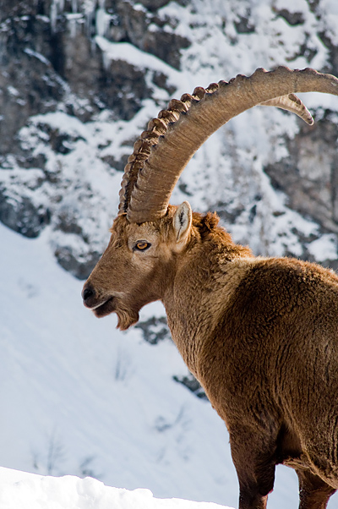
Körper |  | ___________________________________________________________________________________________________________________________
Fell |  | ___________________________________________________________________________________________________________________________
Hörner |  | ___________________________________________________________________________________________________________________________
Hufe |  | ___________________________________________________________________________________________________________________________ | Bild: Wiki Commons
Lebensraum |  | ______________________________________________________________________________________________________________________________________________________________________________________________________________________________
Sozialverhalten |  | ______________________________________________________________________________________________________________________________________________________________________________________________________________________________
Nahrung |  | ____________________________________________________________________________________________________________________________________________________
Feinde |  | ____________________________________________________________________________________________________________________________________________________

