Aufgabe 1
Beschreiben Sie, was mit den Menschen im Film passiert. Was stellen die Ausserirdischen mit den Menschen an? Bleiben Sie sachlich und verzichten Sie darauf, die Ereignisse moralisch zu bewerten.
______________________________________________________________________________________________________________________________________________________________________________________________________________________________________________________________________________________________________________________________________________________________________________________________________________________________________________________________________________________________________________________________________________________________________________________________
Aufgabe 2
Warum ist es schlimm, was mit den Menschen passiert? Weshalb empfinden wir die Taten der Ausserirdischen als ungerecht?
________________________________________________________________________________________________________________________________________________________________________________________________________________________________________________________________________________________________________________________________________________________________________________________________________________________________________________________________________________________________________________________________________________________________________________________________________________________________________________________________________________
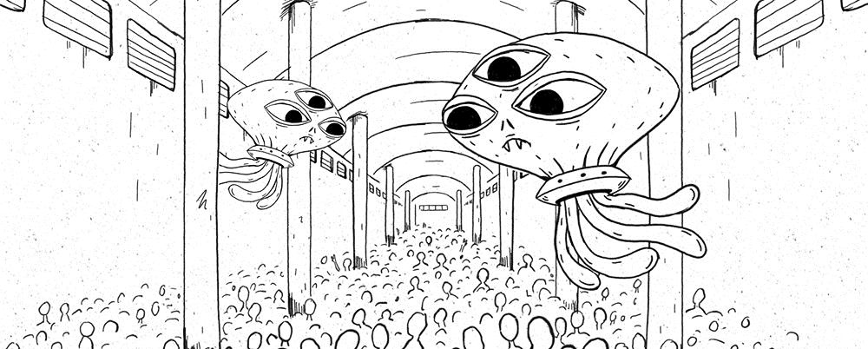
Bild: Filosofix (SRF)

Aufgabe 3
Mit welchen Argumenten rechtfertigt der Anführer der Aliens das Verhalten gegenüber den Menschen?
__________________________________________________________________________________________________________________________________________________________________________________________________________________________________________________________________________________________________________________________________________________________________________________________________________________________________________________________________________________________________________________________________________________________________________________________________________________________________________________________________________________________________________________________________________________________________
Aufgabe 4
Sind die Argumente der Aliens vernünftig und nachvollziehbar? Begründe Sie Ihre Antwort!
__________________________________________________________________________________________________________________________________________________________________________________________________________________________________________________________________________________________________________________________________________________________________________________________________________________________________________________________________________________________________________________________________________________________________________________________________________________________________________________________________________________________________________________________________________________________________
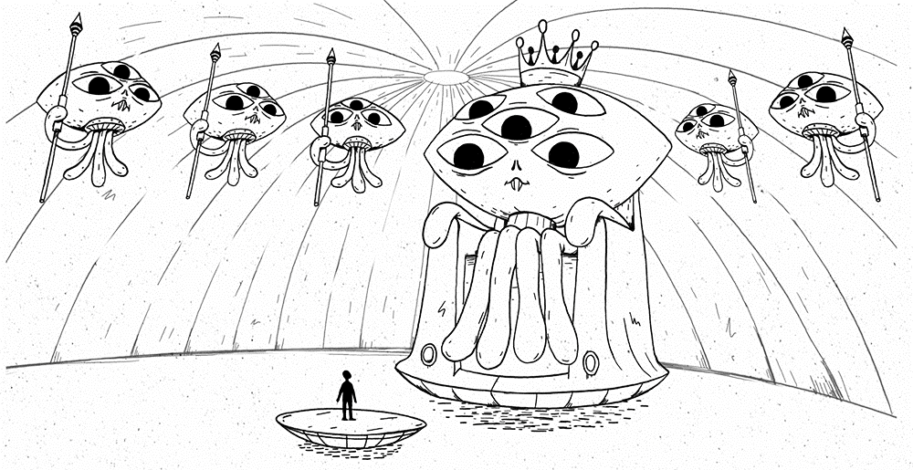
Bild: Filosofix (SRF)

Aufgabe 5
Stellen Sie auf Grundlage des Gedankenexperiments ein Analogieargument dafür auf, dass Tiere dieselben Rechte auf Schutz haben wie Menschen.
- ____________________________________________________________________________________________________________________________________________________________________________________________________________________________________________________________________________________________________________________________
- ____________________________________________________________________________________________________________________________________________________________________________________________________________________________________________________________________________________________________________________________
Daraus folgt:

____________________________________________________________________________________________________________________________________________________________________________________________________________________________________________________________________________________________________________________________
Aufgabe 6
Ist diese Argumentation vernünftig? Begründen Sie Ihre Antwort!
________________________________________________________________________________________________________________________________________________________________________________________________________________________________________________________________________________________________________________________________________________________________________________________________________________________________________________________________________________________________________________________________________________________________________________________________________________________________________________________________________________________________________________________________________________________________________________________________________________________________________________________________________________________________________________________________________________________________________________________________________________________

