Methoden der Früherkennung
1. Analyse von Bimsstein | 2. Aufzeichnung seismischer Aktivitäten | 3. Analyse aufsteigender Gase | 4. Überwachung von Bodendeformationen | 5. Beschiessung mit Druckwellen
-----------------------------------------  -----------------------------------------  -----------------------------------------  -----------------------------------------  -----------------------------------------  -----------------------------------------  -----------------------------------------  -----------------------------------------  -----------------------------------------  -----------------------------------------  -----------------------------------------  -----------------------------------------  -----------------------------------------  -----------------------------------------  -----------------------------------------  -----------------------------------------  -----------------------------------------  -----------------------------------------  -----------------------------------------  -----------------------------------------  -----------------------------------------  -----------------------------------------  ----------------------------------------  ----------------------------------------------------------------------------------  ---------------------------------------------------------------------------------------------------------------------------  -------------------------------------------------------------------------------------------------------------------------------------------------------------------- | -----------------------------------------  -----------------------------------------  -----------------------------------------  -----------------------------------------  -----------------------------------------  -----------------------------------------  -----------------------------------------  -----------------------------------------  -----------------------------------------  -----------------------------------------  -----------------------------------------  -----------------------------------------  -----------------------------------------  -----------------------------------------  -----------------------------------------  -----------------------------------------  -----------------------------------------  -----------------------------------------  -----------------------------------------  -----------------------------------------  -----------------------------------------  ----------------------------------------  -----------------------------------------  ----------------------------------------  -------------------------------------------------------------------------------------------------------------------------------------------------------------------  -------------------------------------------------------------------------------------------------------------------------------------------------------------------- | -----------------------------------------  -----------------------------------------  -----------------------------------------  -----------------------------------------  -----------------------------------------  -----------------------------------------  -----------------------------------------  -----------------------------------------  -----------------------------------------  -----------------------------------------  -----------------------------------------  -----------------------------------------  -----------------------------------------  -----------------------------------------  -----------------------------------------  -----------------------------------------  -----------------------------------------  -----------------------------------------  -----------------------------------------  -----------------------------------------  -----------------------------------------  ----------------------------------------  -----------------------------------------  ----------------------------------------  -------------------------------------------------------------------------------------------------------------------------------------------------------------------  -------------------------------------------------------------------------------------------------------------------------------------------------------------------- | -----------------------------------------  -----------------------------------------  -----------------------------------------  -----------------------------------------  -----------------------------------------  -----------------------------------------  -----------------------------------------  -----------------------------------------  -----------------------------------------  -----------------------------------------  -----------------------------------------  -----------------------------------------  -----------------------------------------  -----------------------------------------  -----------------------------------------  -----------------------------------------  -----------------------------------------  -----------------------------------------  -----------------------------------------  -----------------------------------------  -----------------------------------------  ----------------------------------------  -----------------------------------------  ----------------------------------------  --------------------------------------------------------------------------------------------------------------------------------------------------------------------  -------------------------------------------------------------------------------------------------------------------------------------------------------------------- | -----------------------------------------  -----------------------------------------  -----------------------------------------  -----------------------------------------  -----------------------------------------  -----------------------------------------  -----------------------------------------  -----------------------------------------  -----------------------------------------  -----------------------------------------  -----------------------------------------  -----------------------------------------  -----------------------------------------  -----------------------------------------  -----------------------------------------  -----------------------------------------  -----------------------------------------  -----------------------------------------  -----------------------------------------  -----------------------------------------  -----------------------------------------  ----------------------------------------  -----------------------------------------  ----------------------------------------  -------------------------------------------------------------------------------------------------------------------------------------------------------------------  --------------------------------------------------------------------------------------------------------------------------------------------------------------------
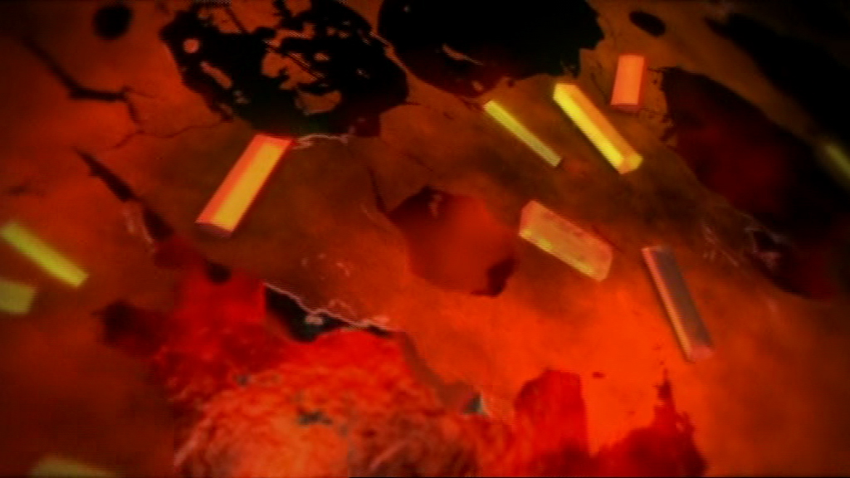 | 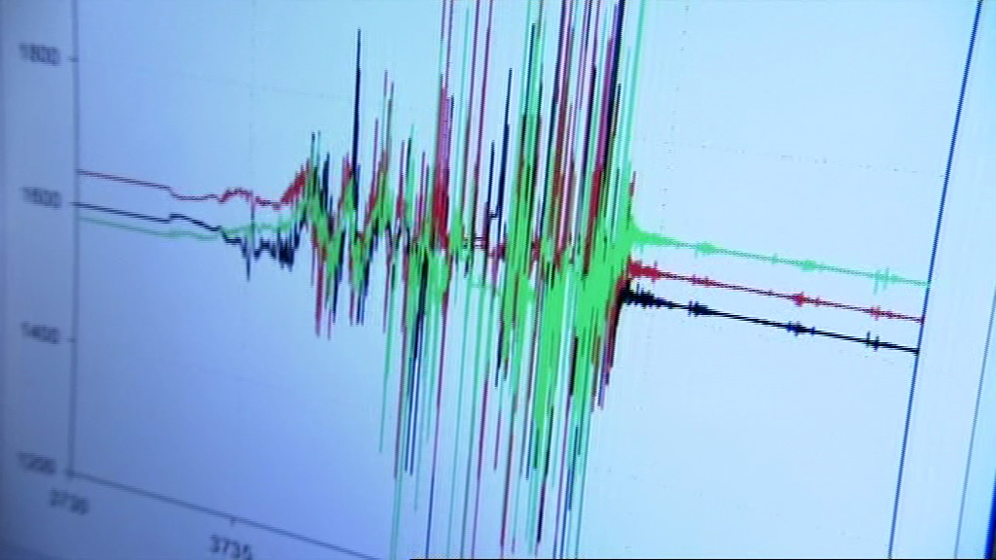 | 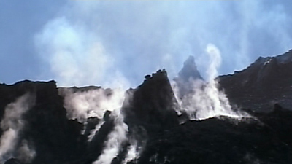 | 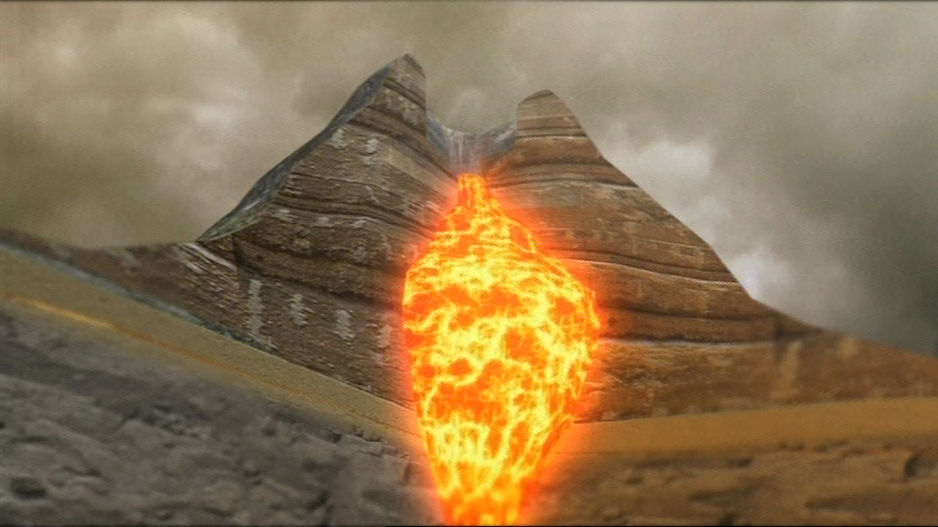 | 