worksheet
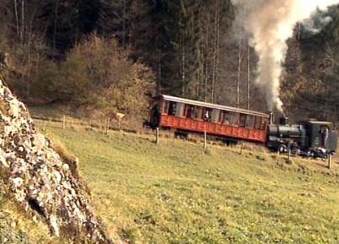

Mountains of Switzerland: The Rigi
Rack railway and Nagelfluh

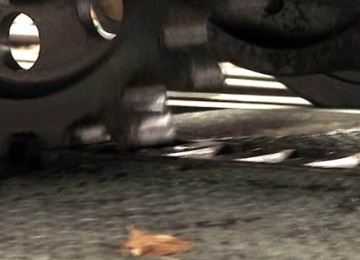 |  | - Where is the valley station of the Rigi Railway?  - Are there any other options to get up the Rigi?  - What gradient does the railway have to master, and how long does the ride to the top last?  - Which three lakes surround the Rigi?  - What is the name of the railway pioneer who built the Rigi Railway? Put its construction into a historical context and ex-plain the advantages of the cogwheel railway over an adhesion railway. Also briefly point out the benefits of the new flexible switch system.  - Name three or more cogwheel railways working on the basis of different cogwheel technologies. Find these railways in the atlas. Make a sketch explaining their different systems.  - When was the heyday of the Belle Epoque? Describe some of the characteristics of that time.  - Draw a sketch of the Rigi's genesis.  - Explain how the pre-Alps and the Rigi formed. The following words may help you in this: Alps, erosion, alluvial cones, mo-lasse, conglomerate, Nagelfluh, slanting bands of rock, to com-pact, to bury, to slide over, to push upward.  - The Rigi is considered the «cradle of tourism». Explain why.  - Various kinds of organised events are supposed to increase the attractiveness of the region. List two or more.
