Solutions to the worksheet
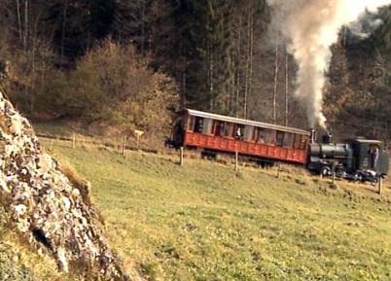

Mountains of Switzerland: The Rigi
Rack railway and Nagelfluh

1. Where is the valley station of the Rigi Railway?
Vitznau

2. Are there any other options to get up the Rigi?
Yes, there are. For example, a cable car from Weggis to Kaltbad or another cogwheel railway from Arth-Goldau via Klösterli to Rigi Kulm.

3. What gradient does the railway have to master, and how long does the ride to the top last?
25 percent, 30 minutes

4. Which three lakes surround the Rigi?
The Lakes of Lucerne, Zug, and Lauerz.

5. What is the name of the railway pioneer who built the Rigi Railway? Put its construction into a historical context and ex-plain the advantages of the cogwheel railway over an adhesion railway. Also briefly point out the benefits of the new flexible switch system.
Niklaus Riggenbach. In operation since 1871; oldest cogwheel rail-way in Europe. The cogwheel railway is able to conquer steeper gradients without slipping or spinning. Mechanical snow clearing of switches replaces the costly and laborious heating of conventional switches.

6. Name three or more cogwheel railways working on the basis of different cogwheel technologies. Find these railways in the atlas. Make a sketch explaining their different systems.
Examples: Pilatus Railway, Locher cogwheel railway system, steep-est cogwheel railway in the world. Jungfrau Railway, Strub cog rail type, highest altitude cogwheel train in Europe. Gornergrat Bahn, Abt rack system, double track.

7. When was the heyday of the Belle Epoque? Describe some of the characteristics of that time.
1885–1914; Impressionism, Art Nouveau

8. Draw a sketch of the Rigi's genesis.
See film stills from time code 12:25 onwards.

9. Explain how the pre-Alps and the Rigi formed. The following words may help you in this: Alps, erosion, alluvial cones, molasse, conglomerate, Nagelfluh, slanting bands of rock, to com-pact, to bury, to slide over, to push upward.
30 million years ago, erosion in the Alps was in full swing. On their north side a huge alluvial cone formed – the molasse. Some five million years ago, the Alps pushed northward over the molasse, burying it underneath, pushing it along or upwards into mountains. In the process, the molasse was compacted into Nagelfluh. This is how the Rigi, with its slanting rock bands, was formed.

10. The Rigi is considered the «cradle of tourism». Explain why.
Individual answers

11. Various kinds of organised events are supposed to increase the attractiveness of the region. List two or more.
Individual answers

