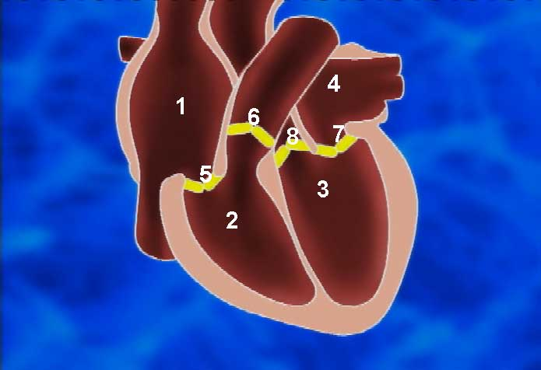
- Right atrium
- Right ventricle
- Left ventricle
- Left atrium
- Valve between right atrium and right ventricle
- Valve between right ventricle and right exit from the heart
- Valve between left atrium and left ventricle
- Valve between left ventricle and left exit from the heart

