worksheet
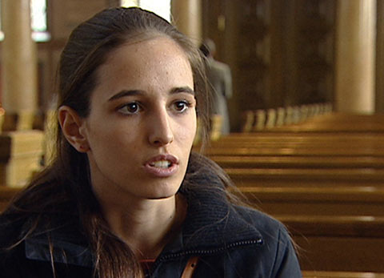

Dossier Religion

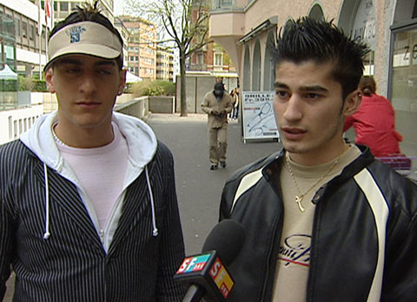 |  | 1. What do you think about the surveys? Which responses do you like best?  2. What do you know about the Christian faith?  3. When did Damaris Sanchez choose to be baptized and how does she practise her Christianity?  4. Why does Damaris think it is important to believe in something?  5. What do you know about Islam?  6. How was Hüseyn Ucmak introduced to Islam? And how does he practise his faith today?  7. How freely or how strictly does Hüseyn’s family follow Islam?  8. What does Hüseyn think about the issue of Islam and violence?  9. What do you know about Judaism?  10. How does Elinor Biro practise the Jewish faith?  11. How strongly is Elinor influenced by her faith?  12. How do you feel about religion and faith?
