worksheet
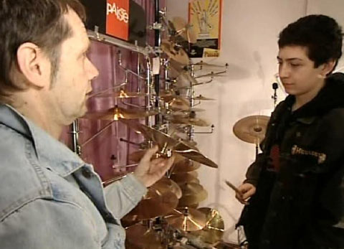

Economy and society
Buying (2)

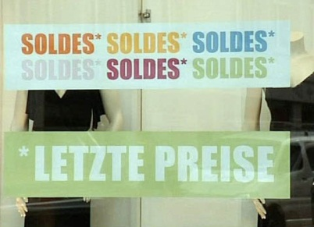 |  | - What is the area of conflict of buyers and sellers?  - Why does Tizian spend all his money on his drums?  - What is the difference between a «maximizer» and a «satisfier»?  - How do you proceed when you make a major purchase?  - What does it depend on if something is buyable or not?  - How does Tizian succeed in keeping his expenses under control?  - What products tend to get cheaper, what products tend to get more expensive?  - Why can most people in Switzerland afford to buy more products and services of everyday life than in the past?  - What is the technical term for the relationship between the consumer prices and the earned income?  - What happens when we decide to buy a particular product?
