Solutions to the worksheet
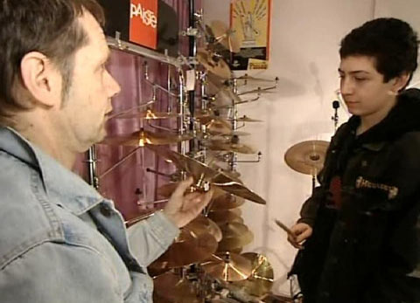

Economy and society
Buying (2)

1. What is the area of conflict of buyers and sellers?
The seller wants to sell, and the buyer may want to buy, but he doesn't want to buy everything. He'd like to buy an especially good, but low-priced product, he'd like to get advice from the salesperson. The salesperson, on the other hand, wants to influence the buyer so he wants to press home many advantages.

2. Why does Tizian spend all his money on his drums?
The drums mean a lot to him. He plays in a band, and spends almost all of his free time with them.

3. What is the difference between a «maximizer» and a «satisfier»?
Maximizers always look for the best product. They compare products and prices. They spend a lot of time looking for all available information before buying. Satisfiers buy immediately if the product more or less meets their requirements.

4. How do you proceed when you make a major purchase?
Individual answers

5. What does it depend on if something is buyable or not?
It always depends on whether there is an offer and a demand for a product or a service, that is to say a buyer and a seller.

6. How does Tizian succeed in keeping his expenses under control?
He draws up a budget.

7. What products tend to get cheaper, what products tend to get more expensive?
Products whose design or production can be improved by techno-logical advances as well as goods that can be mass-produced with machines have usually become cheaper. Goods and services that are labour-intensive have usually become more expensive.

8. Why can most people in Switzerland afford to buy more products and services of everyday life than in the past?
Because in parallel to the prices, the salaries have also risen, in fact, a bit more than the prices.

9. What is the technical term for the relationship between the consumer prices and the earned income?
Purchasing power. The purchasing power measures the proportion of the prices and the salaries. For example, milk: In 1920, the aver-age earner had to work 18 minutes for a litre of milk. Today, it is just four minutes. Milk has become more expensive than in the past, but is cheaper in real terms.

10. What happens when we decide to buy a particular product? The moment you decide, you are convinced that you have made the right decision. This leads to people seeing the product they bought as being worth more and alternative products as being worth less. To maintain this belief, you go and look for information that justifies your choice. You want information about why your choice was the best. You are not going to read a test report that praises a product you didn't buy. We convince ourselves that we've done the right thing.

