worksheet
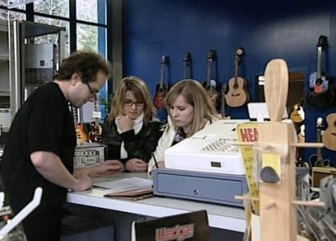

Economy and society
Renting (5)

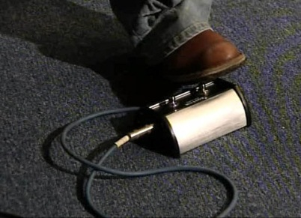 |  | - What are the advantages of renting, according to economist Donato Scognamiglio?  - Name some odd or unusual things that can be rented.  - What factors determine the rent?  - What criteria are important for Angela in selecting a music shop?  - What are Donato Scognamiglio's tips for young renters?  - Even the Bible mentions renting – in which famous story? What is rented?  - What did the Romans hire and rent?  - Name three special forms of rental.  - What issues frequently lead to disputes between landlord and tenant?  - Imagine renting something: would you do it like Caprice, or would you do it differently?  - Of all things, what would you most likely rent?
