Worksheet
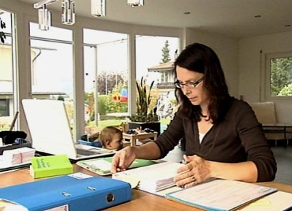

Economy and society
Adult learning (7)

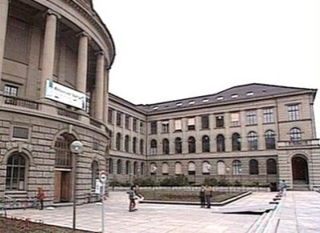 |  | - List some incentives for adult learning.  - Why would craftsmen in former times go on the «Walz»?  - Why do companies invest in training their employees?  - What marks the beginning of further education?  - What are some key factors for choosing the best educational institution?  - What further education does the Swiss government offer?  - How can you avoid qualitatively poor courses?  - What protection against inadequate providers does the Swiss Association for Adult Learning and the Swiss government offer?  - What changes may further education bring with it?  - What differences does André Schläfli note between men and women’s further education?  - How can you find out more about adult learning?  - What type of adult learning would interest you?
