Solutions to the worksheet
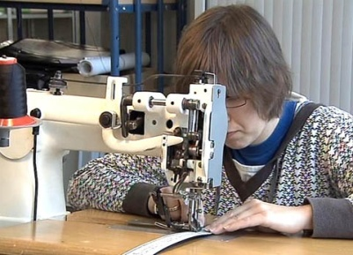

Economy and society
Producing (11)

1. What production processes have you ever taken part in? Describe what that was like.
individual answer

2. The production of Primecut belts at Züriwerk is broken down into many individual steps. Why is that?
This kind of division of labour allows employees to use their individual strengths more specifically and productively.

3. What motivates Züriwerk employees?
Realizing that they are a valuable part of the economy; that their product is in demand and that their belts are actually worn.

4. In what ways is mass production different from individual production? Name advantages and drawbacks of both production types.
mass production: great production quantities, low cost, anonymous production
individual production: small quantities, high cost, products tailored to customers’ needs

5. What different types of production factors feature in the film?
capital equipment: machines, equipment, premises, vehicles
Materials: raw materials, working materials, auxiliary materials, energy. A labor, knowledge: know-how, technologic

6. What are the three business sectors and approximately what percentage of Swiss is employed in each sector?
• Primary sector: agriculture, 4%
• Secondary sector: industry, 30%
• Tertiary sector: service industry, 65%

7. Name some of the greatest changes industrialization brought about.
production in factories; automation of production; rationalisation; replacement of human labour by machines; change in types of jobs; increase of production volume

8. How is labour productivity measured, and how has it changed with regard to Swiss army knives in the last 50 years?
output per worker and time unit (hour or working day)
from six knives per worker and day to 65

9. In which periods of the 20th century did the Swiss GDP per capita fail to grow?
before and during the Second World War; 1974; during the recession following the oil crisis
10. What kinds of undesired negative effects can production processes have?
over-exploitation of natural resources (fish; tropical woods); risk of accidents; exploitation of workers

11. What measures could be taken to combat the negative ef-fects listed in question 10?
Individual answer

12. What kind of product would you like to make yourself? How important would sustainability be for you?
Individual answer

