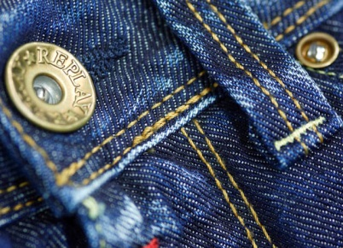
English for PS, Sek I and Sek II

Cultural Phenomena
Blue Jeans (17)

14:30 minutes

1. Who manufactured working clothes from canvas in 1850?
Levi Strauss
2. Which name of an Italian harbour city is hidden in the word «jeans»?
Genoa
3. Which plant gives blue jeans their characteristic blue colour?
Indigo
4. Why do jeans fade to white in some places after being worn for some time?
Only the weft thread on the outside is blue, while the warp thread on the inside is white. Wear makes the weft thread thinner and thinner, so the white core comes to the surface.
5. Can you remember, which countries produce which components of jeans? Which manufacturing steps in the production process take place in which countries?
Possible answers:
- cotton production: India, Kazakhstan
- spinning: Turkey
- indigo: Germany
- weaving: Poland
- inner lining and care instructions: France
- buttons and rivets: Italy
- sewing: Eastern Europe, China, India, Bangladesh
- processing with pumice: Greece
- second hand clothes markets: Africa
6. Dou you know any other product where individual manufacturing steps take place in different countries?
(Individual answers)

7. On what occasions, in your view, would wearing jeans be inappropriate?
(Individual answers)

8. How important are label jeans to you? Why?
(Individual answers)
9. What would you never wear?
(Individual answers)

