Vergleiche die Schädlingsabwehrstrategien des wilden Tabaks mit jener der Limabohne. Was kann die Limabohne, was der wilde Tabak nicht kann (und umgekehrt)?
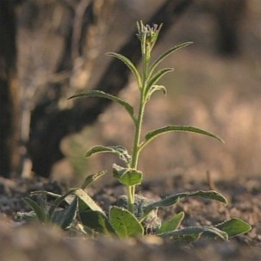  Wilder Tabak | 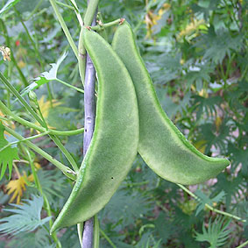  Limabohne
________________________________________________  ________________________________________________  ________________________________________________  ________________________________________________  ________________________________________________  ________________________________________________  ________________________________________________  ________________________________________________  ________________________________________________  ________________________________________________  ________________________________________________ | ________________________________________________  ________________________________________________  ________________________________________________  ________________________________________________  ________________________________________________  ________________________________________________  ________________________________________________  ________________________________________________  ________________________________________________  ________________________________________________  ________________________________________________
________________________________________________  ________________________________________________  ________________________________________________  ________________________________________________  ________________________________________________  ________________________________________________  ________________________________________________  ________________________________________________  ________________________________________________  ________________________________________________  ________________________________________________ | ________________________________________________  ________________________________________________  ________________________________________________  ________________________________________________  ________________________________________________  ________________________________________________  ________________________________________________  ________________________________________________  ________________________________________________  ________________________________________________  ________________________________________________
________________________________________________  ________________________________________________  ________________________________________________  ________________________________________________  ________________________________________________  ________________________________________________  ________________________________________________  ________________________________________________  ________________________________________________  ________________________________________________  ________________________________________________ | ________________________________________________  ________________________________________________  ________________________________________________  ________________________________________________  ________________________________________________  ________________________________________________  ________________________________________________  ________________________________________________  ________________________________________________  ________________________________________________  ________________________________________________
Alle Bilder: Kluge Pflanzen

