Fill in the empty spaces below, according to the numbers in the picture!
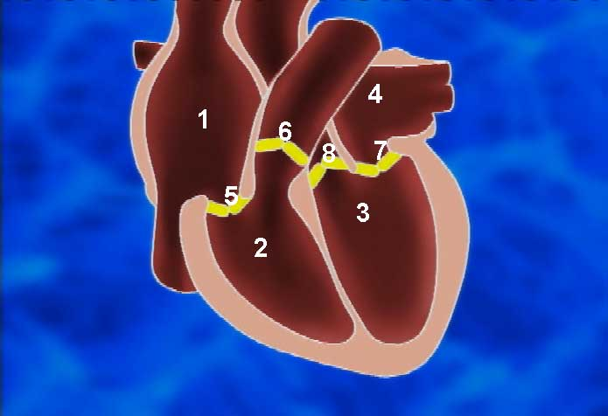
1.
2.
3.
4.
5.
6.
7.
8.

