Solutions to the worksheet
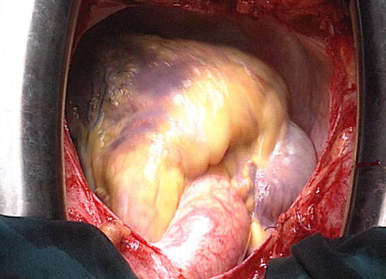

Dossier Heart
The pump

- How many times does our heart beat in one day?
It beats about 100’000 times a day.

- How much blood does it pump around our body in one day?
It pumps 6’000 to 8’000 litres of blood around our body.

- How many times (on average) does an adult’s heart beat during sleep?
It beats about 60 times a minute.

- How many times (on average) does an adult’s heart beat during strenuous physical effort?
It beats about 180 times a minute.

- What are the functions of our heart?
It has the function of a pump which keeps up the blood circulation.

- Explain the pump function of the heart and the blood circulation.
The right half pumps blood into the lungs. There, the blood tanks up with oxygen and then flows back into the heart. The left half pumps blood through the body, where it provides organs and cells with oxygen and nutrients before flowing back into the right half.

- When does the heart of a human being begin to beat for the first time?
It already begins to beat in the fifth week of pregnancy.

- What are the differences between the heart of a baby and an adult’s heart?
A baby’s heart beats about 150 times a minute, the one of an adult only about 75 times. The heart of an adult is much heavier and its cross section measures four times more than at birth.

- How many times (on average) does the heart of an old person beat?
about 50 times a minute

- Give three degenerative heart failures.
cardiac arrhythmia, blocked coronary arteries (Angina Pectoris, heart attack), calcified or weakened valves, pathological enlargement of the ventricles or the heart muscle

- Why are heart and circulatory diseases the number one cause of death in Switzerland?
We have already brought under control the infectious illnesses, which means that more and more people today reach an age in which they feel the degenerative effects on the heart. Furthermore, our lifestyle today is not very healthy for the heart: cigarettes, alcohol, lack of movement, overweight, fatty diet, stress etc.

- Give three methods to treat and/or cure heart diseases.
pacemaker, heart catheter with an inflatable balloon, bypass, reconstructed valves

