Beschrifte das Bild und beschreibe es anschliessend in einigen Sätzen!
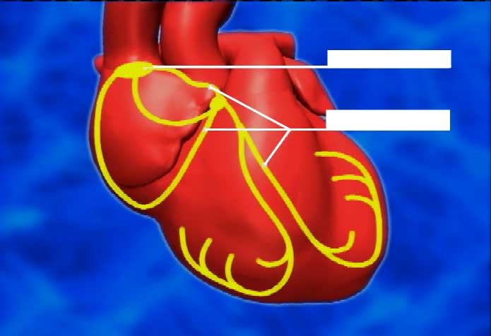
fibres
sinoatrial node
A regular heartbeat is ensured by the sinoatrial node above the right atrium, the heart’s control centre, and by special fibres throughout the heart. Electrical impulses from the sinoatrial node cause the heart to contract rhythmically.

