Describe how the blood flows through the heart!
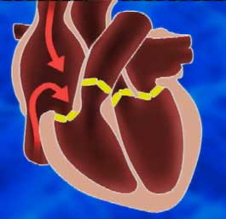 |  |  | 1. The blood flows into the right atrium.
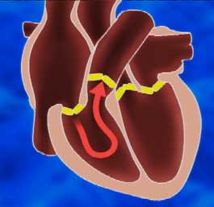 |  |  | 2. From the right atrium the blood flows into the right ventricle.
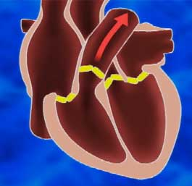 |  |  | 3. From the right ventricle the blood flows into the lungs.
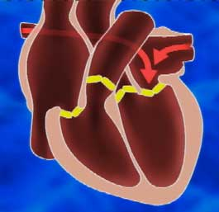 |  |  | 4. From the lungs the blood flows back into the left atrium.
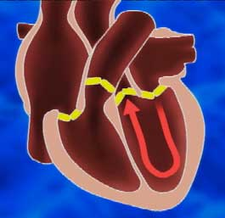 |  |  | 5. From the left atrium the blood flows into the left ventricle.
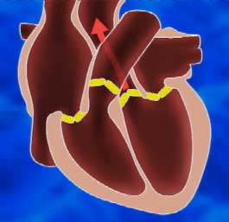 |  |  | 6. From the left ventricle the blood flows into the entire body, providing organs and cells with oxygen. It then flows back into the right atrium.

