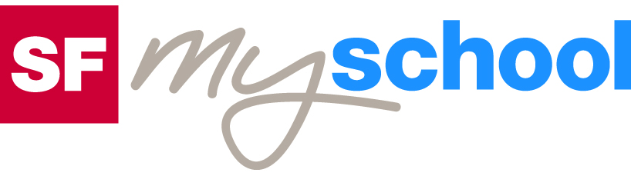 |  |  |  | Worksheet
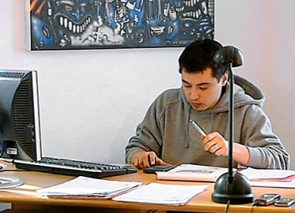
 |  | Economy and society
 |  | Starting a business (10)

- Imagine starting your own business. What product or service would you sell?

- What success factors do the students at the beginning of the film name? Can you add any more?

- What skills must good entrepreneurs bring to the job?

- What personality traits should an entrepreneur possess?

- What drawbacks are there to being self-employed?

- Which examples for successful business ideas are mentioned in the film? Can you add any more?

- What does SME stand for? What is the maximum number of employees at a Swiss SME company? What percentage of Swiss companies are SMEs?

- Which legal form do most Swiss companies prefer for them-selves? Why is this not an option for One Truth?

- What advantages and drawbacks does a so-called general partnership have for One Truth?

- According to the expert in the film, what are the defining characteristics of the limited liability company?

- Name the two business areas of One Truth and their respective target groups

- Should the Swiss government provide incentives for more companies to be founded? Why (not)?
