worksheet
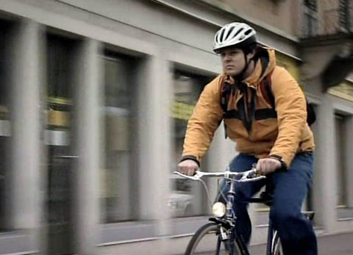

Traffic – the rules of the road
12. The invisible cyclist

09:45 minutes
Two-track audio
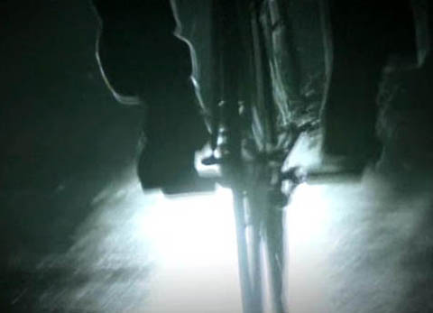
1. Where is Christoph going on the night of his accident?

2. What unusual profession has Christoph got?

3. Briefly discuss the relative strength of cyclists in traffic.

4. What accessories increase cyclists' visibility?

5. What colours should cyclists wear?

6. List the legal requirements for bicycle lights.

7. What do we call the generator of a bicycle's light?

8. What injuries do cyclists often sustain? How can they protect themselves?

9. How often do you ride your bike? When did you last cycle somewhere? What lights did your bicycle have?

10. Have you ever experienced a road accident – directly or indirectly? Describe what happened and what caused the accident.

