worksheet
Cultural Phenomena

Hygiene (18)

14:45 minutes
Two-track audio

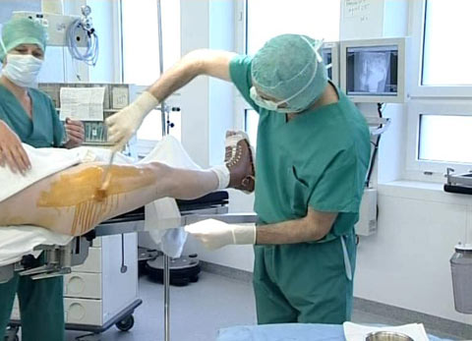 |  | - What do you know about the Middle Ages and about hygiene in the Middle Ages?  - How was the level of hygiene in the 19th century?  - What rules of hygiene does the Kantonsspital Winterthur have?  - Why can gastric infections occur in a hospital – despite all hygienic measures?  - Write down each single step of sterilising the surgical instruments in a hospital.  - Describe the rules of hygiene in the kitchen of the hospital.  - Why are sewage plants important?  - Explain the level of hygiene in poor countries.  - In your opinion: What is part of hygiene in everyday life?  - What do you expect of other people concerning hygiene? What do you consider too much?  - What consequences does lacking personal hygiene have in the professional life, in private life?
