Schau dir die deiner Gruppe zugeteilte Sequenz aus dem Beitrag «News» an und beantworte die Fragen.

1. News, Definition (TC 00:00-03:32)
- Was sind News?
------------------------------------------------------------------------------------------------------------------------------------------------------------------------------------------------------------------------------------------------------------------------------------------------------------------------------------------------------------------------------------------------------------------------------------------------------------------------------------------------------------------------------------------------------------------------------------------------------------------------------------------------------------------------------------------------------------------

- Wozu braucht man News-Journalisten?
------------------------------------------------------------------------------------------------------------------------------------------------------------------------------------------------------------------------------------------------------------------------------------------------------------------------------------------------------------------------------------------------------------------------------

- Was sind News aus der Sicht des stellvertretenden Redaktionsleiters der Tagesschau?
------------------------------------------------------------------------------------------------------------------------------------------------------------------------------------------------------------------------------------------------------------------------------------------------------------------------------------------------------------------------------------------------------------------------------

- Warum brauchen Menschen Nachrichten? Was denkt die Kommunikationswissenschaftlerin Schönhagen?
------------------------------------------------------------------------------------------------------------------------------------------------------------------------------------------------------------------------------------------------------------------------------------------------------------------------------------------------------------------------------------------------------------------------------

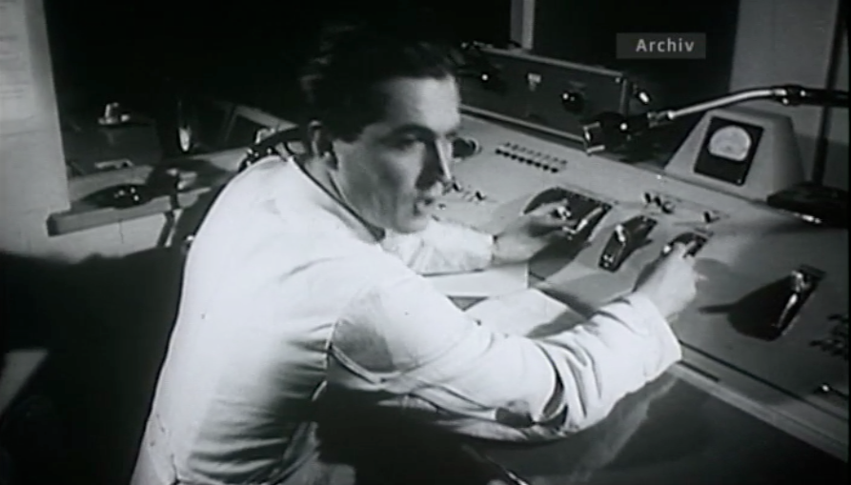 | 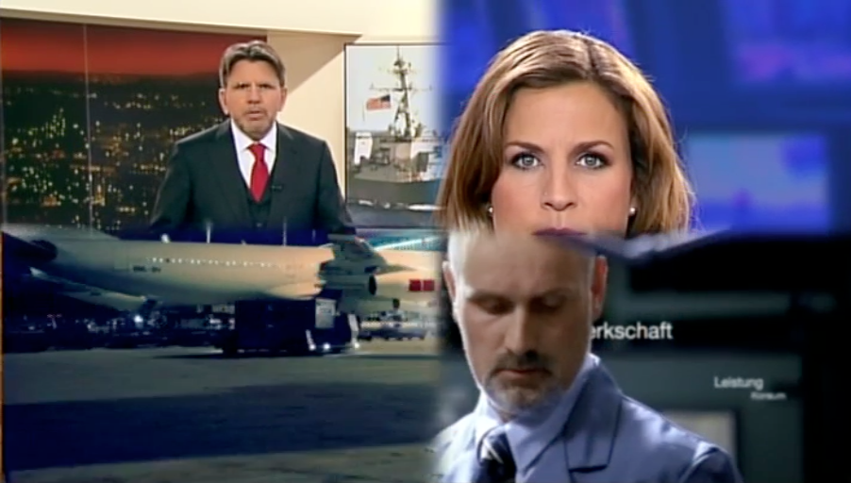 | 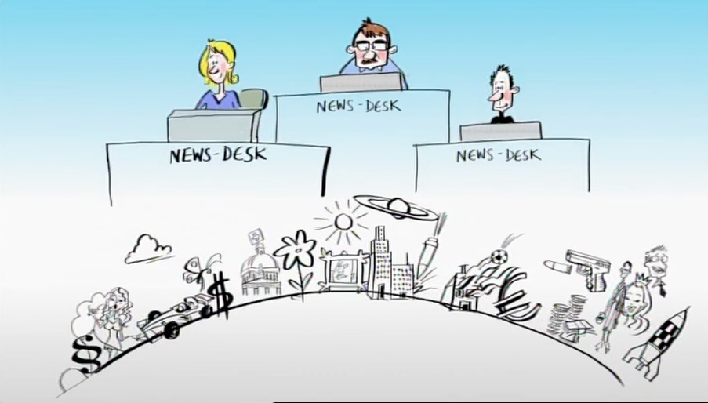

2. Hard-News und Soft-News (TC 03:31–06:36)
- Wie unterscheidet sich die Aufarbeitung des Zugunglücks in Finnland im Blick und bei der NZZ?

------------------------------------------------------------------------------------------------------------------------------------------------------------------------------------------------------------------------------------------------------------------------------------------------------------------------------------------------------------------------------------------------------------------------------

- Was versteht man unter Hard-News und Soft-News?

Hard-News | Soft-News
------------------------------------------------------------------------------------------------------------------------------------------------------------------------------------------------------------------------------------------------------------------------------------------------------------------------------------------------------------------------------------------------------------ | ------------------------------------------------------------------------------------------------------------------------------------------------------------------------------------------------------------------------------------------------------------------------------------------------------------------------------------------------------------------------------------------------------------------------

- Sollen Nachrichten unterhaltsam sein? Welche Argumente nennen die befragten Passanten?

Pro | Contra
------------------------------------------------------------------------------------------------------------------------------------------------------------------------------------------------------------------------------------------------------------------------------------------------------------------------------------------------------------------------------------------------------ | ------------------------------------------------------------------------------------------------------------------------------------------------------------------------------------------------------------------------------------------------------------------------------------------------------------------------------------------------------------------------------------------------------------------

- Was hält Kommunikationswissenschaftlerin Schönhagen von Infotainment?

------------------------------------------------------------------------------------------------------------------------------------------------------------------------------------------------------------------------------------------------------------------------------------------------------------------------------------------------------------------------------------------------------------------------------------------------------------------------------------------------------------------------------------------------------------------------------------------------------------------------------------------------------------------------------------------------------------------

 | 3. Manipulation (TC 06:40-08:12) und Medienfreiheit (TC 08:12-10:14)
- Worauf müssen News-Journalisten im Umgang mit PolitikerInnen oder Personen aus der Wirtschaft achten?

------------------------------------------------------------------------------------------------------------------------------------------------------------------------------------------------------------------------------------------------------------------------------------------------------------------------------------------------------------------------------------------------------------------------------------------------------------------------------------------------------------------------------------------------------------------------------------------------------------------------------------------------------------------------------------------------------------------

- Was versteht man unter Medienfreiheit?

------------------------------------------------------------------------------------------------------------------------------------------------------------------------------------------------------------------------------------------------------------------------------------------------------------------------------------------------------------------------------------------------------------------------------------------------------------------------------------------------------------------------------------------------------------------------------------------------------------------------------------------------------------------------------------------------------------------

- Warum ist Medienfreiheit/Pressefreiheit wichtig?

------------------------------------------------------------------------------------------------------------------------------------------------------------------------------------------------------------------------------------------------------------------------------------------------------------------------------------------------------------------------------------------------------------------------------------------------------------------------------------------------------------------------------------------------------------------------------------------------------------------------------------------------------------------------------------------------------------------

 | 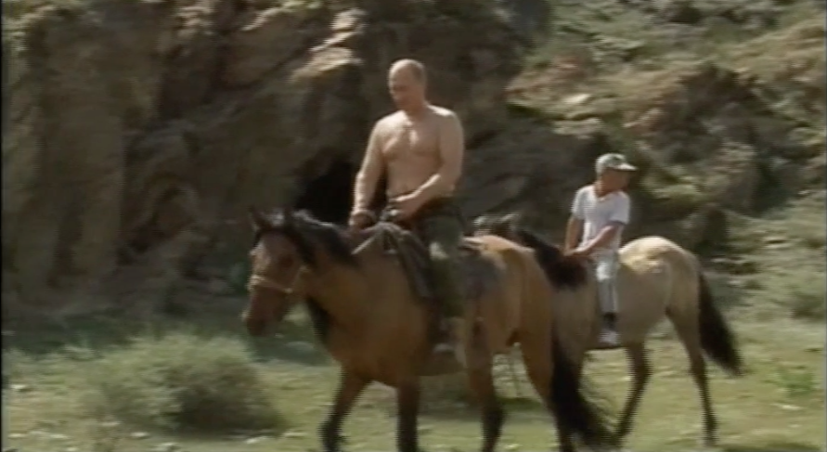 | 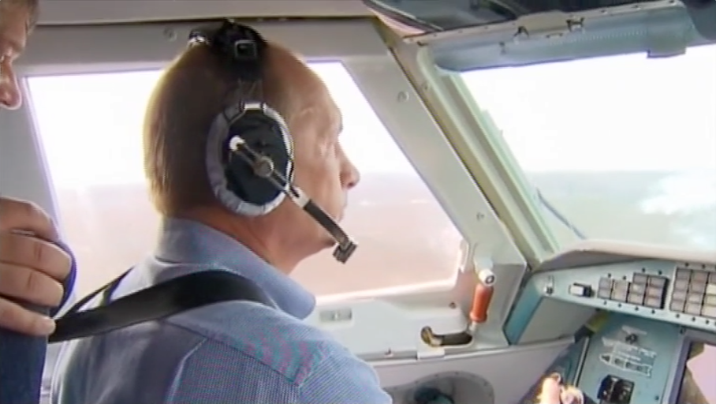 | 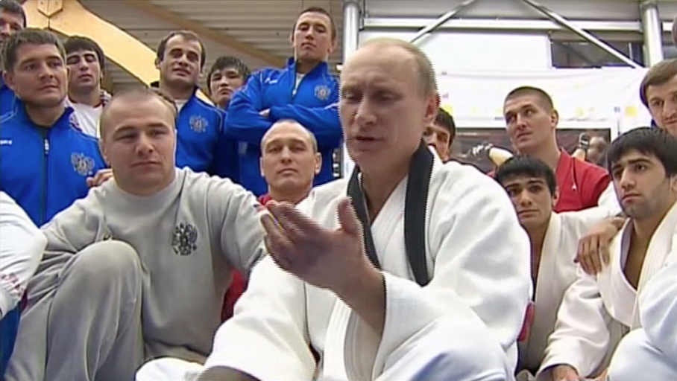

4. Kontrolle (TC 10:14-12:22)
- Was darf die Presse nicht?

------------------------------------------------------------------------------------------------------------------------------------------------------------------------------------------------------------------------------------------------------------------------------------------------------------------------------------------------------------------------------------------------------------------------------------------------------------------------------------------------------------------------------------------------------------------------

- Was sind wichtige journalistische Grundsätze?

------------------------------------------------------------------------------------------------------------------------------------------------------------------------------------------------------------------------------------------------------------------------------------------------------------------------------------------------------------------------------------------------------------------------------------------------------------------------------------------------------------------------------------------------------------------------

- Wer kontrolliert die Medien?

------------------------------------------------------------------------------------------------------------------------------------------------------------------------------------------------------------------------------------------------------------------------------------------------------------------------------------------------------------------------------------------------------------------------------------------------------------------------------------------------------------------------------------------------------------------------

