Before watching
Exercise 1: The United Kingdom consists of four different countries with four different capital cities. Can you write the information from the list below in the correct box?

Exercise 2: Brighton is a town on the south coast of England. Can you pinpoint it on the map?
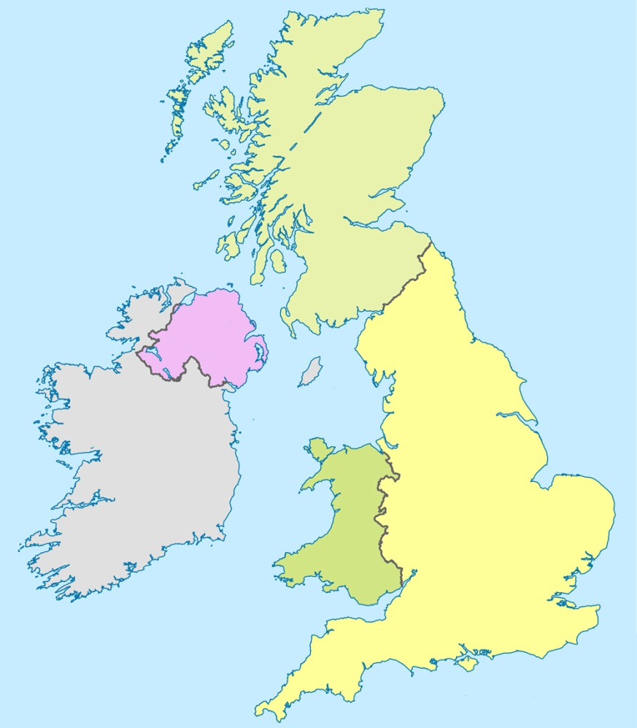
………………………………………………………………………………………………
………………………………………………………………………………………………
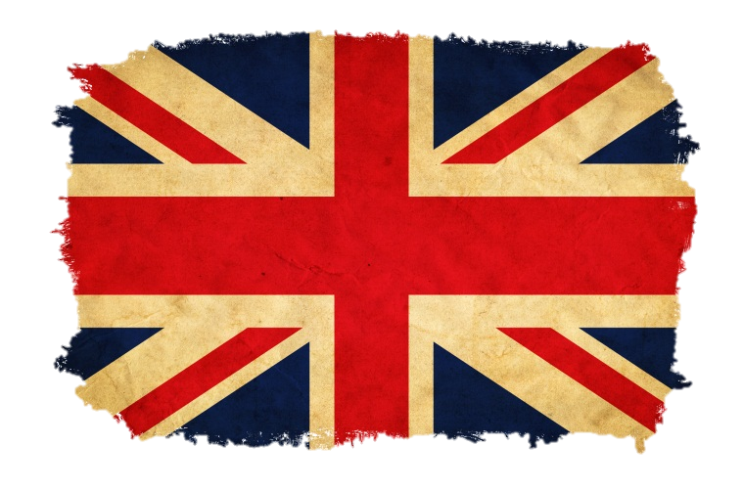

England ………………………………………………………………

Bild: Colourbox

Brighton
East Sussex
Pop. 273‘400
………………………………………………………………………………………………

Bild: Wikipedia

Country | Capital City | Population
England | Cardiff | 3 million
Wales | London | 50 million
Scotland | Belfast | 5 million
Northern Ireland | Edinburgh | 1,5 million

Before watching
Exercise 3: Here are some interesting facts about Brighton. Read them for 5 minutes as often as possible and try to memorize them. When the time is up your partner will read the facts to you again, but be careful: Your partner will read each sentence with one mistake in it! Can you find it?
- Brighton is one of England’s most popular seaside resorts. The town has a population of about 270’00 and is located on the south coast, about 90 km south of London.

- During the 19th century, Brighton became popular with day trippers from London, who came by train. The town also became a fashionable health resort, and bathing in seawater was widely practiced.

- Today Brighton attracts about 8 million visitors each year.

- It has been voted the UK’s coolest town and one of the happiest towns in the country.

- The town has been featured in books by Graham Greene, Henry James and Jane Austen. It has been featured in over 40 films, including the classic 1947 film «Brighton Rock».

- The «London to Brighton Veteran Car Run» dates from 1896 and is the world’s longest running motoring event. Participating cars must have been made before 1905 and cannot go faster than 32 km per hour.

- Brighton’s Grand Hotel was built in 1864 and when it opened, had the country’s only lift outside London. In 1984 a bomb exploded in the hotel in an attempt to kill the Prime Minister, Margaret Thatcher.

- Brighton’s most famous building is the Royal Pavilion, designed to look like an oriental palace. It was built for the Prince of Wales during the 18th century and was used as a hospital during World War I.

- One of the most interesting areas of Brighton is the Lanes, a maze of narrow streets. This popular shopping area is well known for antiques, fashion and jewellery.

- Brighton Pier opened in 1823 and is over 580 metres long. The pier is illuminated by 70’000 lights and the Isle of Wight can be seen from the helter skelter.

- The town has almost 100 parks and gardens, and over 400 restaurants, more per person than anywhere except London. It also has Britain’s oldest purpose built cinema, dating from 1910.
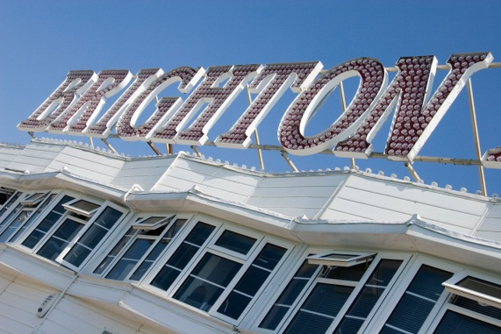  Bild: VisitBrighton |  | 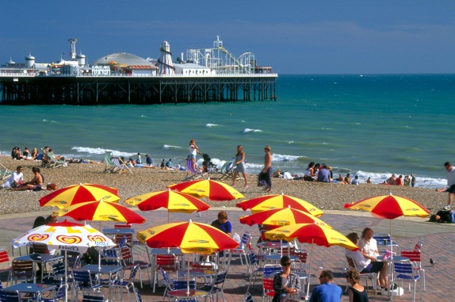  Bild: VisitBrighton

Before watching
Exercise 4: Now here are the same facts again but in every sentence are two mistakes. Underline and correct them.
- Brighton is one of England’s most popular countryside resorts. The town has a population of about 270’000 and is located at the south coast, about 90 km south of London.

- During the 19th century, Brighton became popular with daily commuters from London, who came by train. The town also became a fashionable health resort, and sleeping in seawater was widely practiced.

- Today Brighton attracts about 28 million visitors each century.

- It has been voted the UK’s coldest town and one of the happiest towns in the world.

- The town has been featured in books by Graham Greene, Henry James and Austen Powers. It has been featured in over 40 films, including the classic 1947 film «Brighton Crap».

- The «London to Brighton Oldtimer Car Run» dates from 1896 and is the world’s longest running motoring event. Participating cars must have been made before 1805 and cannot go faster than 32 km per hour.

- Brighton’s Grand Hotel was built in 1864 and when it opened, had the country’s only light bulb outside London. In 1984 a bomb exploded in the hotel in an attempt to kill the Prime Minister, Margaret Cameron.

- Brighton’s most famous building is the Royal Pavilion, designed to look like an arabic palace. It was built for the Prince of Wales during the 18th century and was used as a bunker during World War I.

- One of the most interesting areas of Brighton is the Lanes, a gaze of narrow streets. This popular shopping area is well known for antiques, fashion and furniture.

- Brighton Airport opened in 1823 and is over 580 metres long. The pier is illuminated by 70’000 lights and the Isle of Kite can be seen from the helter skelter.

- The town has almost 100 punks and gardens, and over 400 restaurants, more per person than anywhere except London. It also has Britain’s oldest purpose built zoo, dating from 1910.
Exercise 5: Investigate the exciting backround of the word «helter skelter» and create a 5 short (5 minutes) presentation including some pictures for the class.

Exercise 6: Write down ten facts about your hometown (or a city you know well or like). To make it more exciting you can include some mistakes and challenge your classmates to find them.

